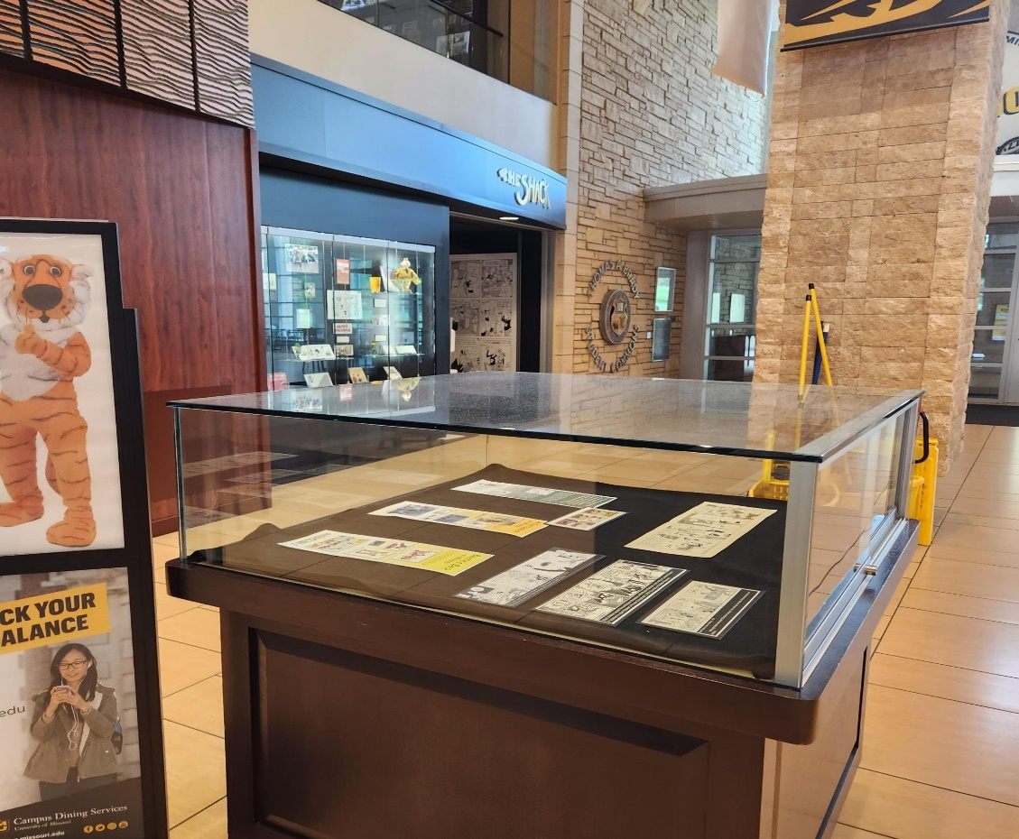

Figure 1: First Floor square case, between Panda Express and Morts.

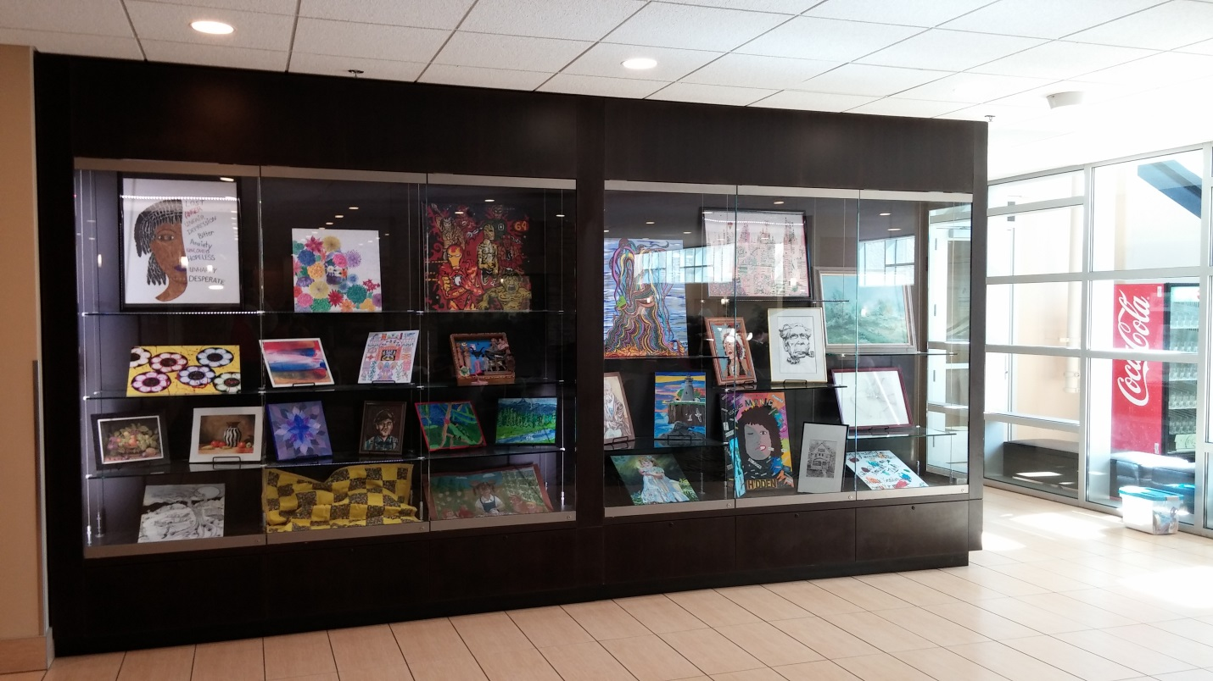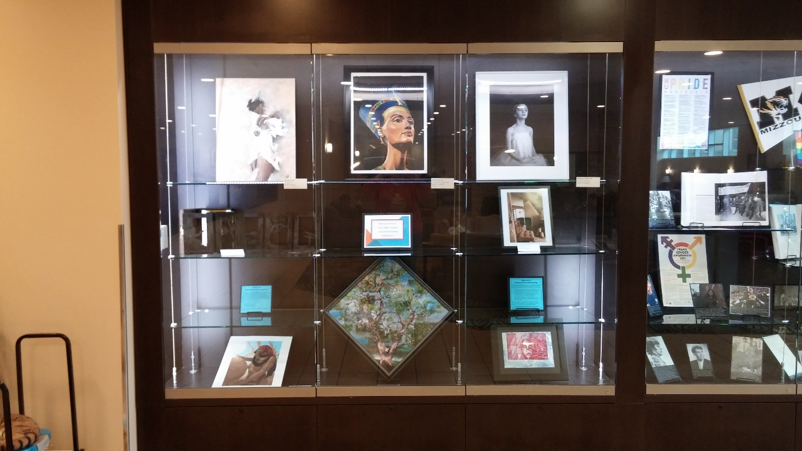

Figure 2: Lower Lounge glass-front cases, east wall

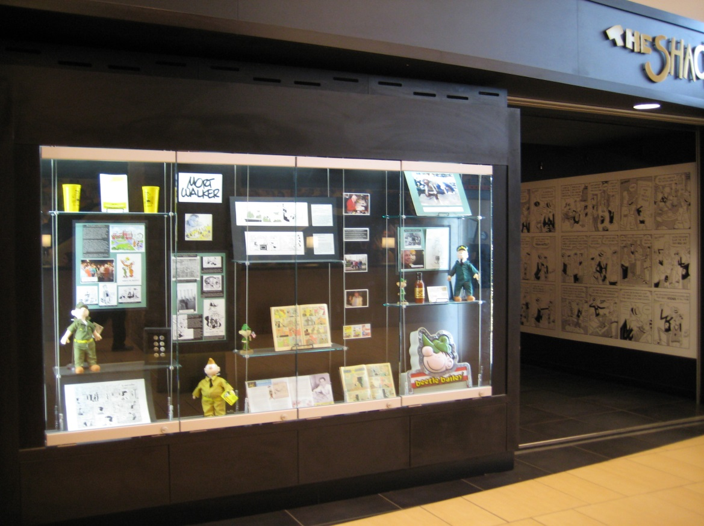

Figure 3: Mort Walker case, first floor near the entrance to Shack area