**How To Create An On-Line Organization Election Using Western Link**

1. Log in to Western Link ([www.westernlink.ca](http://www.westernlink.ca))

2. Go to your organization/club page

3. Click on Elections on the left side of the page.

4. Click the “Create Election” button.

CreateElection.png

5. Choose a name for your election. (Example: Baking Club Elections Spring 2014)

6. Check the box “Include Instructions”

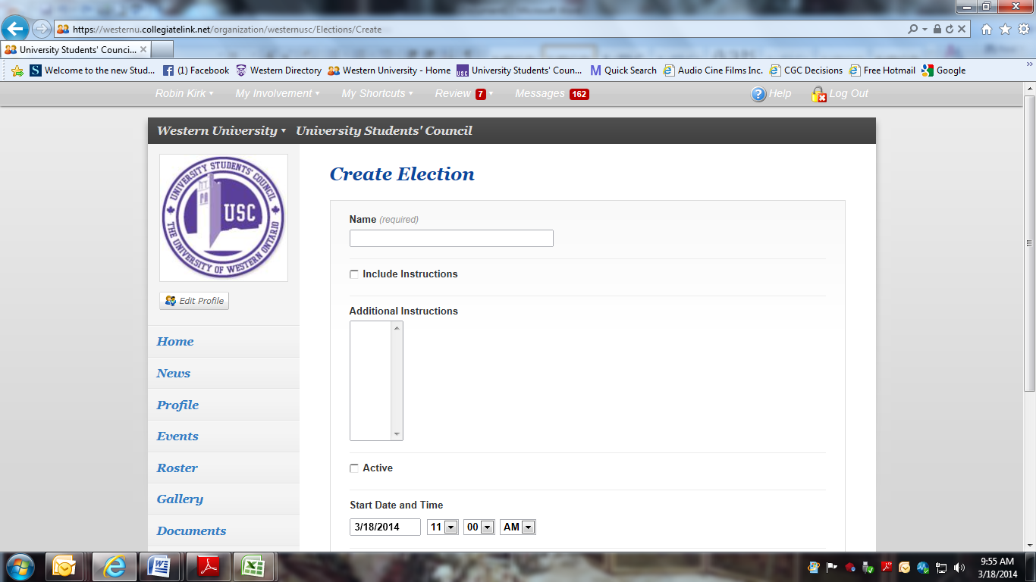

7. Check the box “Active”. This will make the online election live and ready to accept votes.

8. Choose a date range you would like the election to be open for. The system will start and stop accepting votes at these dates and times.

9. You can choose to have an alert on the main page of your organization. Please see yellow highlighted section below for an example. Students can click on ‘Vote Now!’ as it is a hyperlink to the election page.

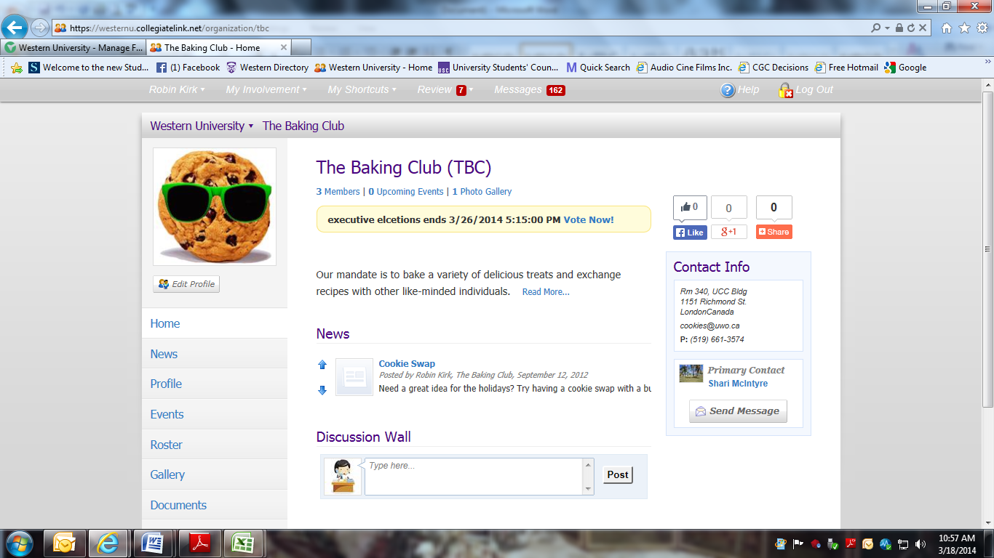

10. Click on the box “Only allow users *[club members]* listed on the roster of this organization to vote.”

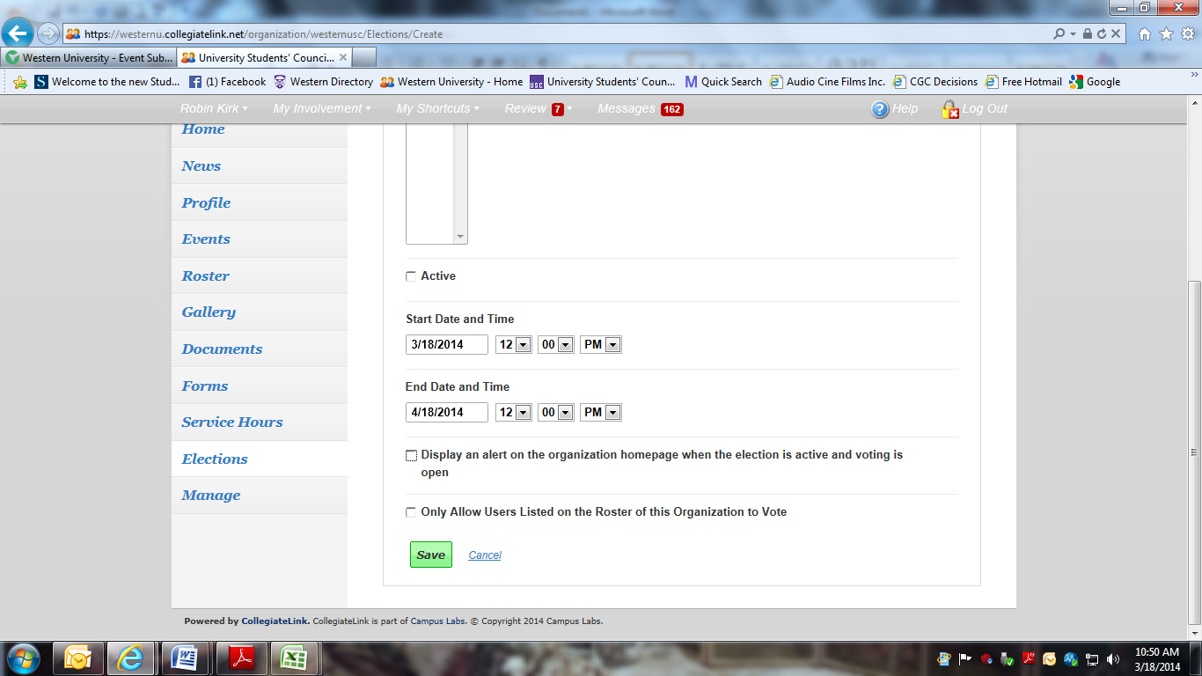

11. Click “Save”.

You need to create a ballot for each position (President, VP Finance, VP Events, VP Communications)

12. Click “Create Ballot”.

CreateBallot.png

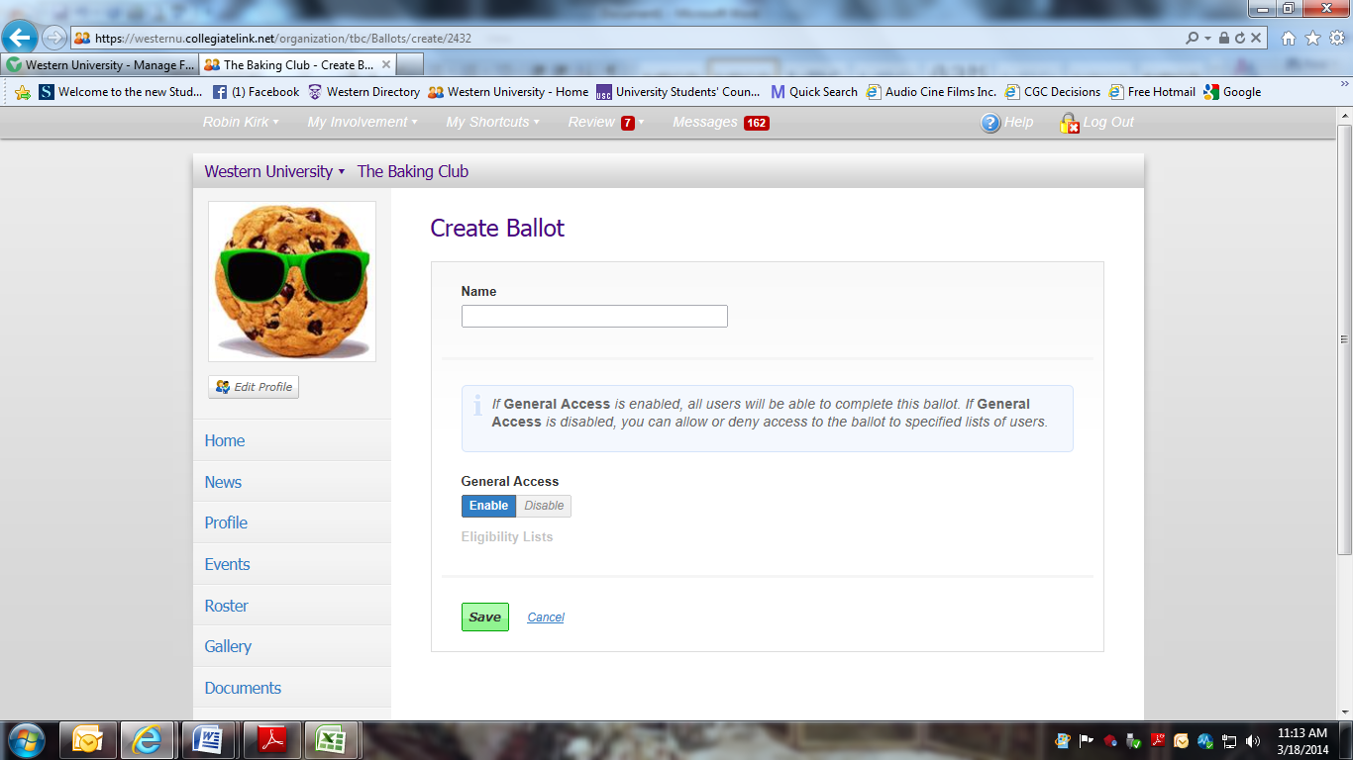

13. Choose a name for your ballot. (Example: Club President)

14. This ballot should be available to all registered users [*club members*]. Make sure the ‘Enable’ side is highlighted.

BallotGenAccessSlider.png

15. Click “Save

16. You are now taken to a new page where you can create a ballot.

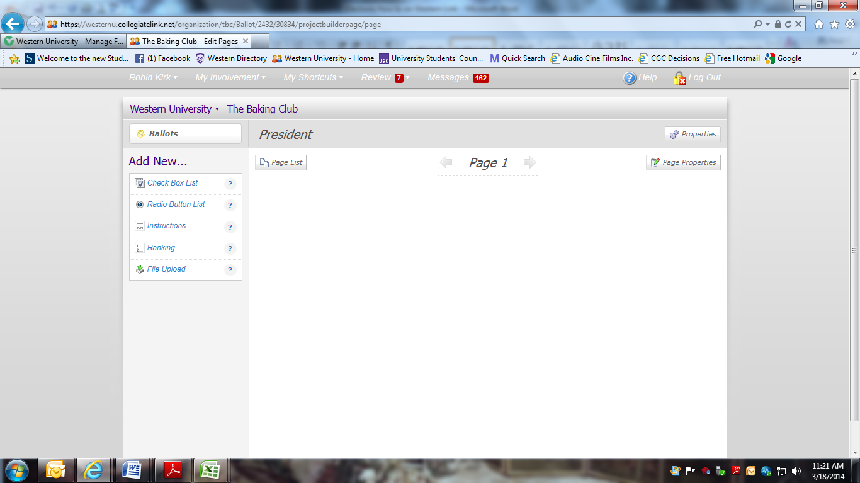

17. Click on “Check Box List”

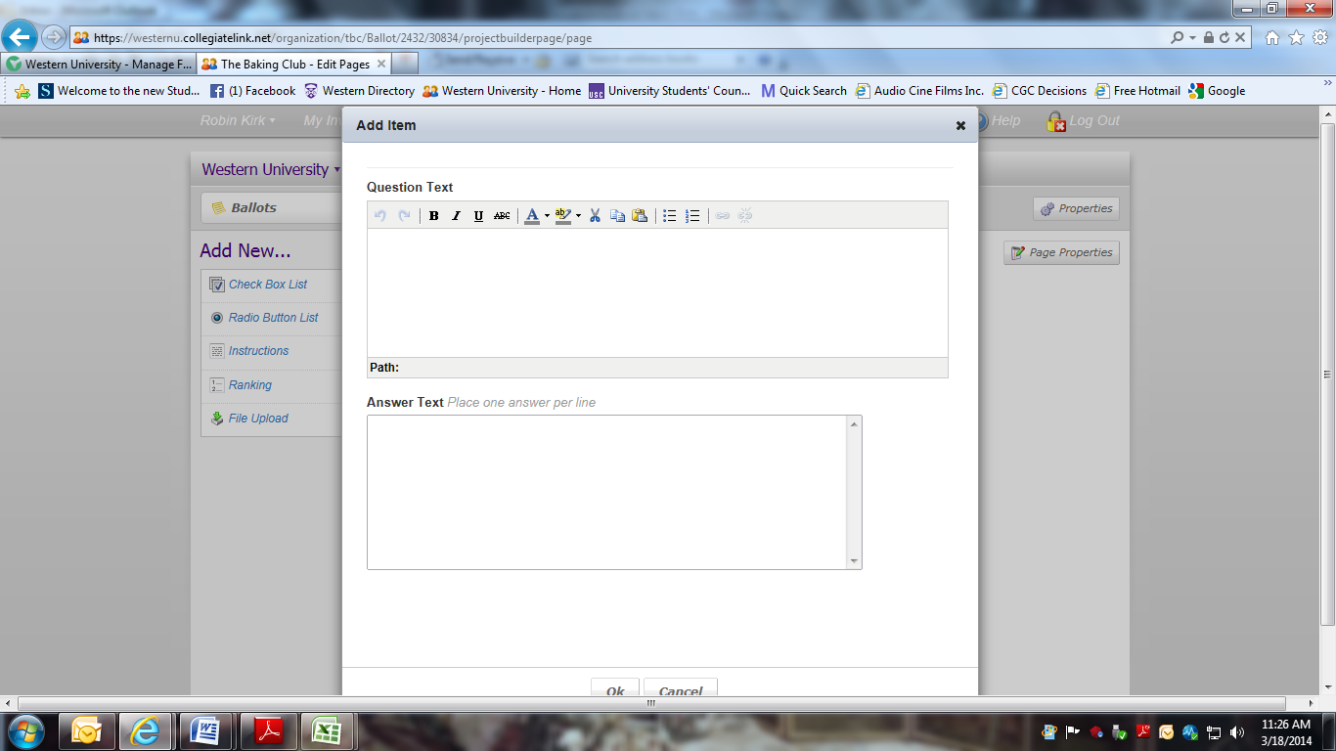

18. In the ‘Question Text’ add the information you wish to convey to the club members about this part of the vote. (Example: “Please choose the name of the person you wish to be the President of the club for the 2014-2015 academic year.”)

19. Add the names of each person running for President (one per line). If you wish to add more information about each candidate it can be inserted here. (Brief answers to some questions you sent out in the request for nominations).

These names should be listed in Alphabetical order so no preference is given.

20. Click ‘OK’

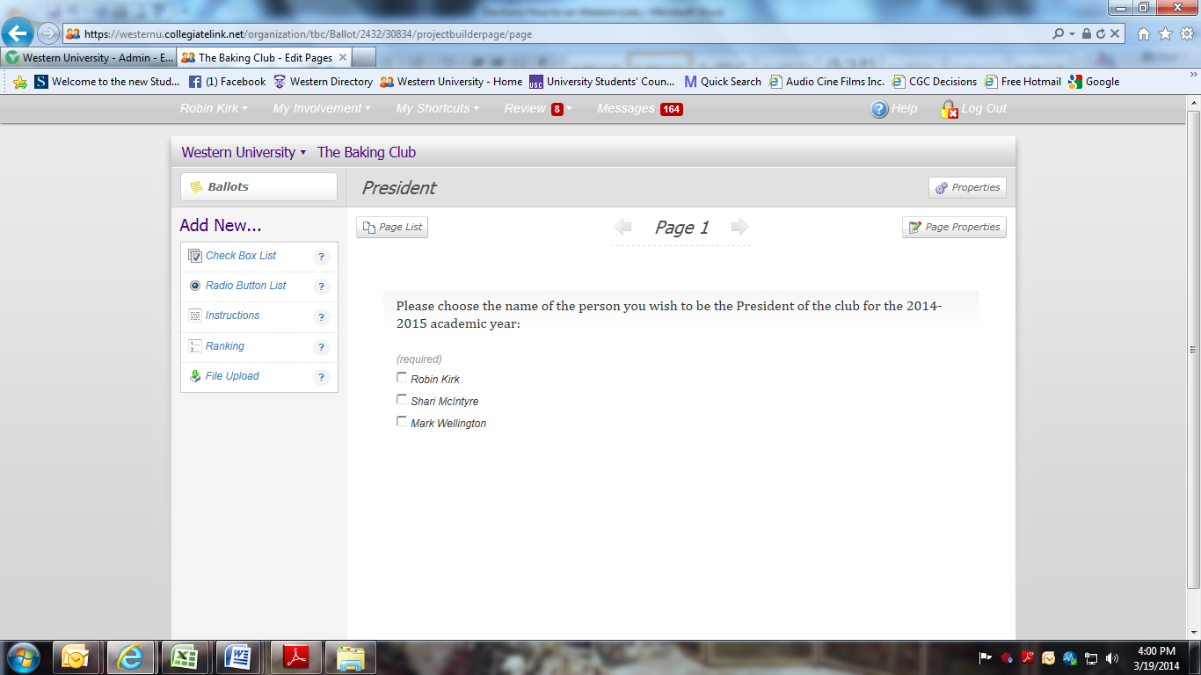

21. If you need to make changes to this ballot, click on the question and an ‘edit’ button will appear. Click on ‘Edit’ to make your changes.

22. To create more ballots for other positions (VP Finance, VP Events and VP Communications) click on the ‘Ballots’ tab in the upper left corner of this page.

Ballots.PNG

23. Repeat steps 17-20 for each ballot needed.

You have now built your election.

24. To leave this section, click on the ‘Ballots’ tab in the upper left corner.

25. You will be back on the main page. From here, click on the 4th tab ‘Publishing Options’.

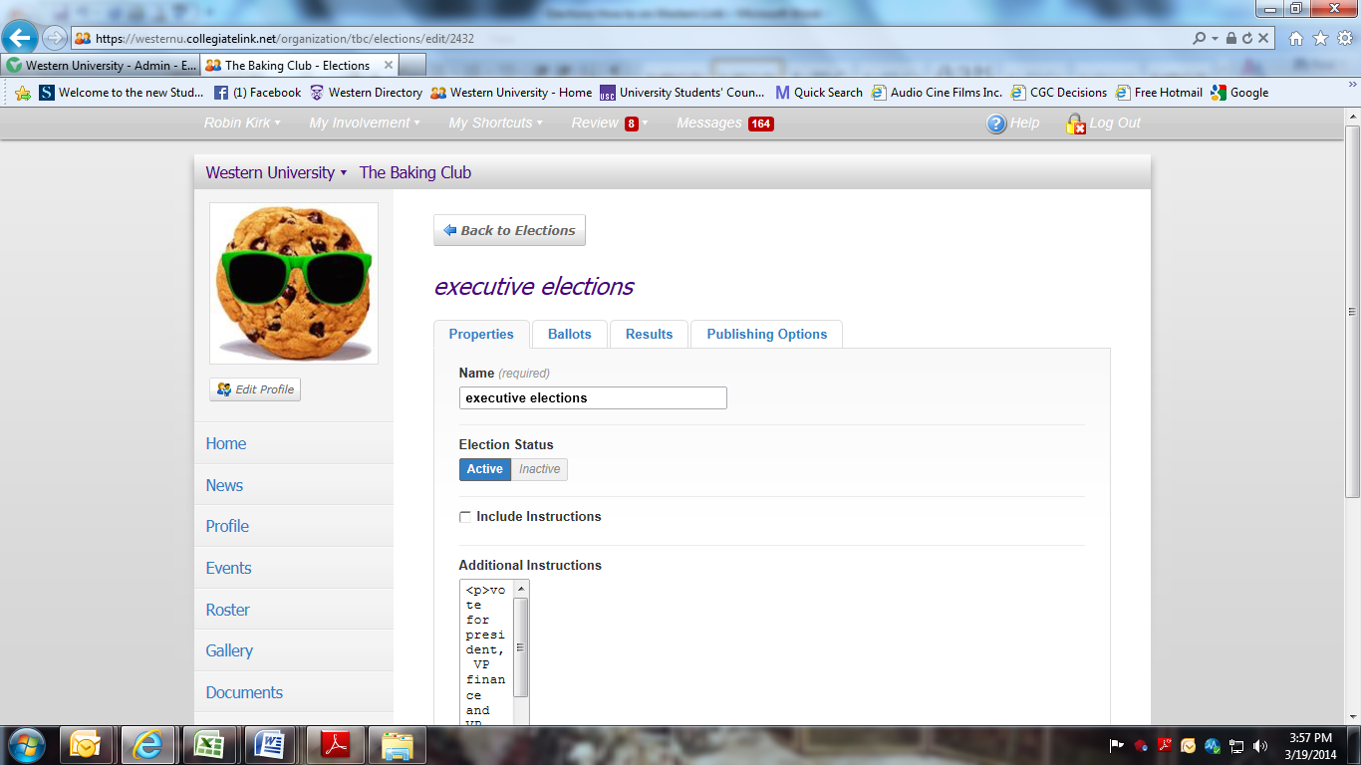

26. You will be shown the “Election Link” (see below). This is what you will need to send to your club members in your information email about your club election.

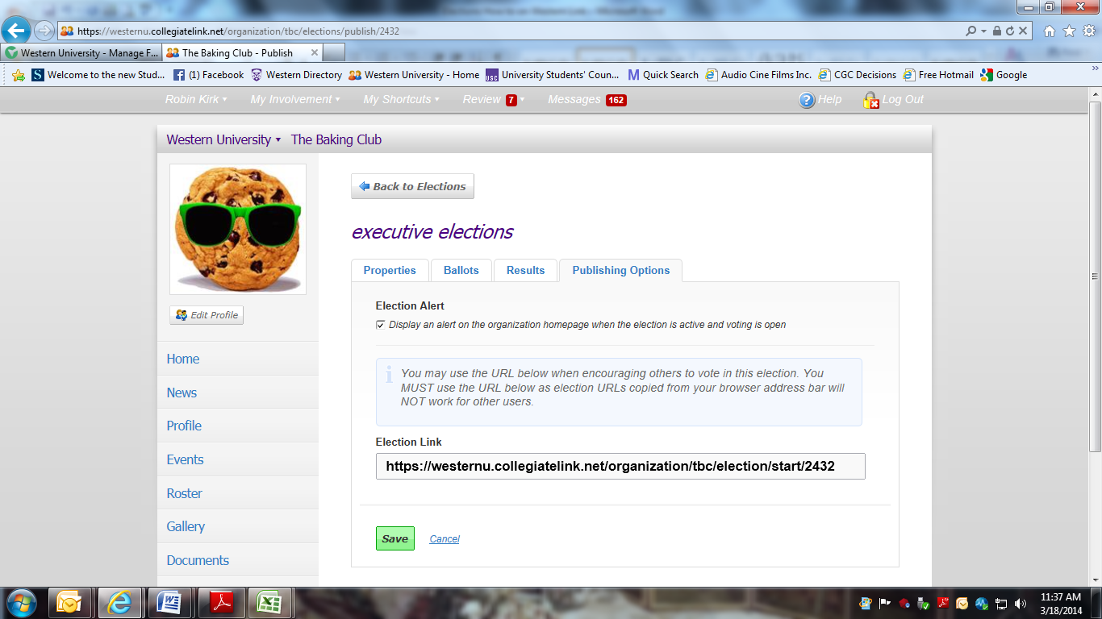

27. Click ‘Save’ and you are done!