Operations Crew Manual
2015-2016

Table of Contents
Table of Contents | Page 2
Job Description & Expectations | Page 3
Dress Code | Page 4
Room Setups | Page 5
Performance Indicators  Pride Appraisal | Page 6-7  Page 8-10
Disciplinary Actions | Page 11
When to Work  SSO  Time Clock Plus  Training/Checklist | Page 12-17  Page 18-21  Page 22-23  Page 24

Job Description
The Building Operation student staff provides assistance for the daily operations of the Sam Rayburn Student Center. They have the responsibility of setting up rooms for meetings and events, help keep the building clean, and assist building managers when necessary.

Expectations
- Perform all duties in a professional manner and in accordance with University and student center policies involving reservations.
- Maintain a clean and neat work area.
- Monitor lounges and clean/straighten furniture as needed.
- Regularly inspect rooms scheduled for appropriate arrangements according to the Daily Set-up Worksheet.
- Familiarize yourself with services and resources available at the student center.
- Assist with signage directing guests to specific locations within the student center.
- Appropriate attire includes your nametag, radio, and clean pressed clothing.
- Assist in monitoring activity in the student center.
- Report any employee concerns, problems, or equipment missing or broken to immediate supervisor.
- Assist with keeping storage rooms clean, neat and organized.
- Performs other duties as assigned to maintain an optimal work environment at the student center.

Dress Code
Appropriate Attire
- RSC Polo
- Jeans
- Belt
- Nice Shoes
- Name Badge
- Polo, Jeans nicely pressed.
- RSC weekend shirt (Fri-Sun)

Inappropriate Attire
- Shorts
- Open toe shoes
- No name badge
- Non RSC shirt or polo
- Weekend shirt (Mon-Thurs)
- No organizations paraphernalia showing

Room Setups

Audience (30) Classroom (18)

XXXXX XXXXX x x x x
XXXXX XXXXX x x x x
XXXXX XXXXX x x x x

Open Square (12) Closed Square (20)
x x x x x x x x x x x x x
x x x x x x x x x x x x x
x x x x x x x x x x x
x x x x
U – Shape Outside only U – Shape Outside / Inside
x x
x x x x x x
x x x x x x
x x x x x x
x x x x x x x x x x
x x x x x x x x x x x x

Performance Indicators
(Based on a 1-5 scale with 5 being the highest)
- Employee arrives to work on time (Employees are required to be here five minutes before shift starts)
  - Late five or more times per semester
  - Late four times per semester
  - Late three times per semester
  - Late Two times per semester
  - Late one time per semester
- Employee wears appropriate work uniform
  - Five or more uniform violations per semester
  - Four uniform violations per semester
  - Three uniform violations per semester
  - Two uniform violations per semester
  - One uniform violation per semester
- Employee prepares an independent operations plan
  - Never prepares a plan
  - Has to be told to prepare a plan
  - Prepares plan a hour into shift
  - Prepares plan 30 minutes into shift
  - Prepares a plan as soon as shift begins
- Employee communicates with prior shift employees to insure set up sheet accuracy and anything else that is needed to be completed by end of shift
  - Never communicates with co-workers
  - Communicates half way through the shift
  - Communicates a hour into shift
  - Communicates thirty minutes into shift
  - Communicates right away with co-workers
- Employee remains available throughout the entire shift for any set up changes
  - Never available for set up changes
  - Mostly unavailable for set up changes
  - Available
  - Checks with manager on room set ups thirty minutes after every event
  - Checks with manager at beginning and thirty minutes after every event
- Employee maintains good customer reports on The Customer Service Survey
  - Five or more customer complaints per semester
  - Four customer complaints per semester
  - Three customer complaints per semester
  - Two customer complaints per semester
  - One customer complaint per semester
- Employee remains versatile in their job duties and takes on every task that is assigned to them with a positive and professional attitude.
  - Does no more than expected
  - Does what is asked with negativity
  - Does what is asked only
  - Does what is asked with a positive attitude
  - Does what needs to be done without being asked
- Employee is never in one conversation for longer than five minutes unless that time is needed to resolve a building issue
  - Five or more excessive conversations per semester
  - Four excessive conversations per semester
  - Three excessive conversations per semester
  - Two excessive conversations per semester
  - One excessive conversation per semester

Employee Performance Appraisal
SRSC Standard of Excellence: PRIDE – P. (Person-Centered Approach), R. (Reach New Heights), I. (Initiative), D. (Dedication), E. (Enthusiasm)

PRIDE – SRSC Experts demonstrate a person-centered approach to customer service, strive to reach new heights, take initiative in their daily actions, exhibit dedication to their positions and the team, and let their enthusiasm be contagious.

Employee: Position:

Original Date of Hire: Date of Evaluation:

Supervisor: Job Title:

INSTRUCTIONS

Mark the appropriate rating for each Evaluation Item based on overall performance.

Key: 5=Excellent, 4=Above Average, 3=Average, 2=Fair, 1=Poor

SRSC STANDARDS OF EXCELLENCE 5 4 3 2 1 n/a
1 | P – Person Centered Approach | Provides each guest with a unique experience. Focuses on the person in addition to the task and takes an individualized approach to customer service.  Examples: Wears uniform & name tag; remains alert to customer needs; approachable at all times; listens for opportunities to add value or suggest additional sales/services; goes the extra mile for a guest; stays focused on work/customers (doesn’t visit with friends or conduct personal business while on shift); works through problems with dissatisfied customers
2 | R – Reach New Heights | Strives to improve our facilities, programs, and services. Be the best you can be and together we will achieve success!  Examples: Suggests new ideas to improve programs or processes within area; volunteers to take on a special project; goes above and beyond on a regular basis

SRSC STANDARDS OF EXCELLENCE cont. 5 4 3 2 1 n/a
3 | I – Initiative | Each staff member has a unique contribution to make. Look around; see how you can make a difference!  Examples: Asks clarification from supervisor when uncertain about procedures; recognizes and performs tasks without being told; stays current on changes, promotions, specials, etc. and actively seeks/shares new information; voluntarily assists co-workers as needed; is aware of potential problem situations and alerts supervisor
4 | D – Dedication | Through individual commitment to our positions and to the team, we will achieve greatness. Show up early, exceed expectations, support one another, and see results.  Examples: “On time” arrival for work; no missed shifts; knows job duties and demonstrates competence during interactions; knows and enforces facility policies; completes all assigned tasks; implements policy and/or procedural changes effectively; attends team/department meetings; respects co-workers; handles problems with co-workers in a professional manner
5 | E – Enthusiasm | A positive attitude drives us to success. Sharing optimism with others is the greatest gift. Let your smile be contagious.  Examples: Smiling; encourages others; is able to leave personal matters at home; demonstrates positivity
6 | EMERGENCY PREPAREDNESS | Knows emergency procedures; knows what to do and remains calm following emergency announcements, evacuations, power shutdowns, etc.

SPECIFIC AREA EXPECTATIONS 5 4 3 2 1 n/a
1
2
3

OVERALL APPRAISAL

5 4 3 2 1 n/a
Demonstrated performance of SRSC standards of excellence

OVERALL APPRAISAL: Write any overall comments you have regarding this employee. Elaborate on areas that this employee scored excellent or poor and suggest ways he/she may improve job performance.

Insert text

GOALS: Outline some goals this employee will work to accomplish during the next semester/year.
- Insert 2-3 suggests that you talk through with student during evaluation

RECOMMENDATION:
Insert proposed raise if applicable.

EMPLOYEE COMMENTS:
Comments from Employee:

_____________________________ ________________________
Employee Signature Date
_____________________________ ________________________
Supervisor Signature Date

Disciplinary Actions

1. First offense will result in a “Verbal Warning”.
- Can be terminated for first offense if necessary
2. Second offense will result in a “Written Warning”.
- Can be terminated for second offense if necessary
3. Third offense will result in “Probation/Suspension”.
- Can be terminated for third offense if necessary
4. Fourth offense will result in “Termination”.

When dealing with Disciplinary Actions you will have the opportunity when called into your supervisor’s office to discuss the incident and what will occur if necessary.

When to Work
When to Work: Program to view your schedule, preferred hours you would like to work according to school schedule, request time off, trade shifts, and view who is currently working.
1. Visit When to Work.com
2. Login with “Sign in ID” and “Password”
3. Set work preferences
4. Set Notifications
5. Trade shifts
6. Request time off

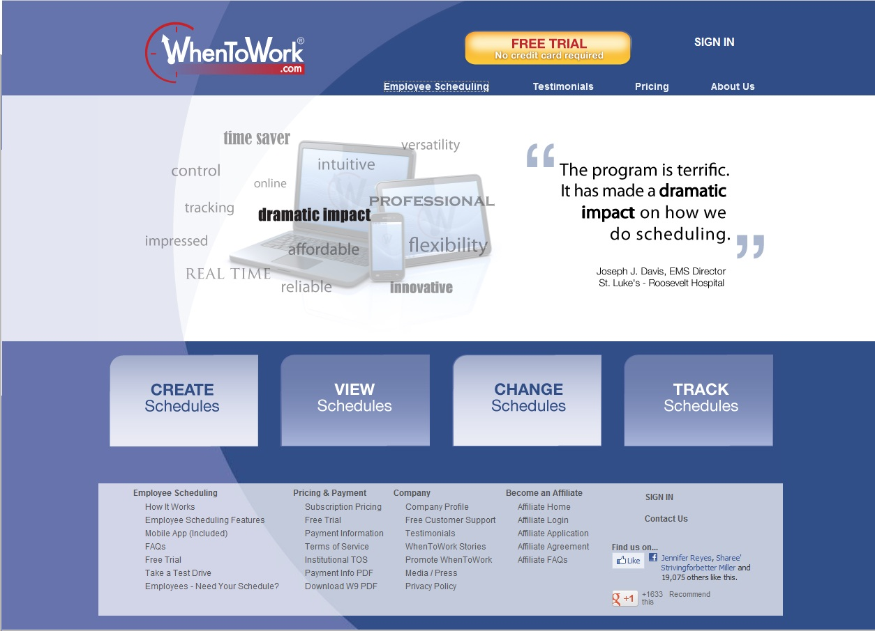
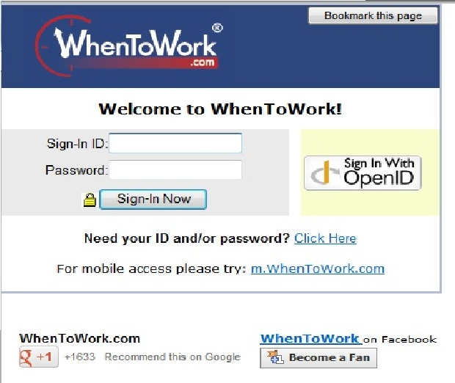
Setting Work Preferences:
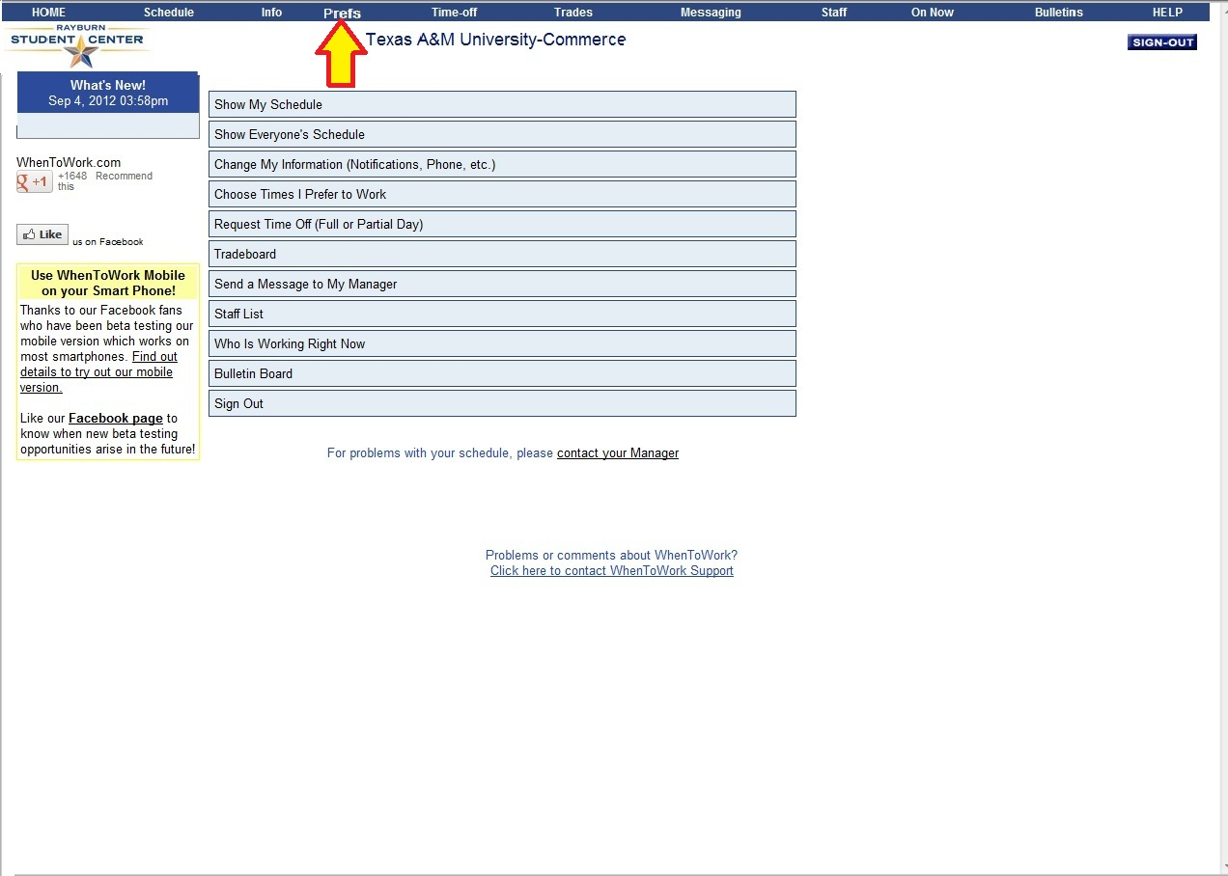
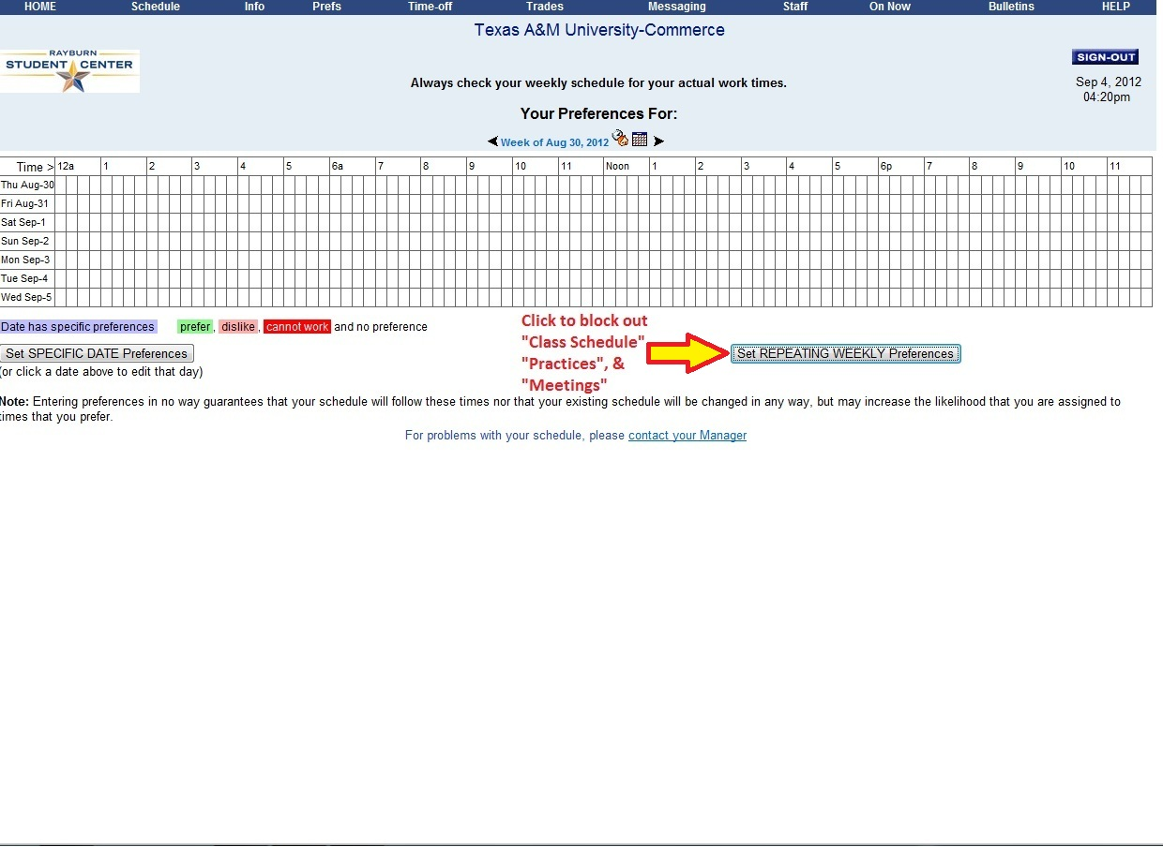
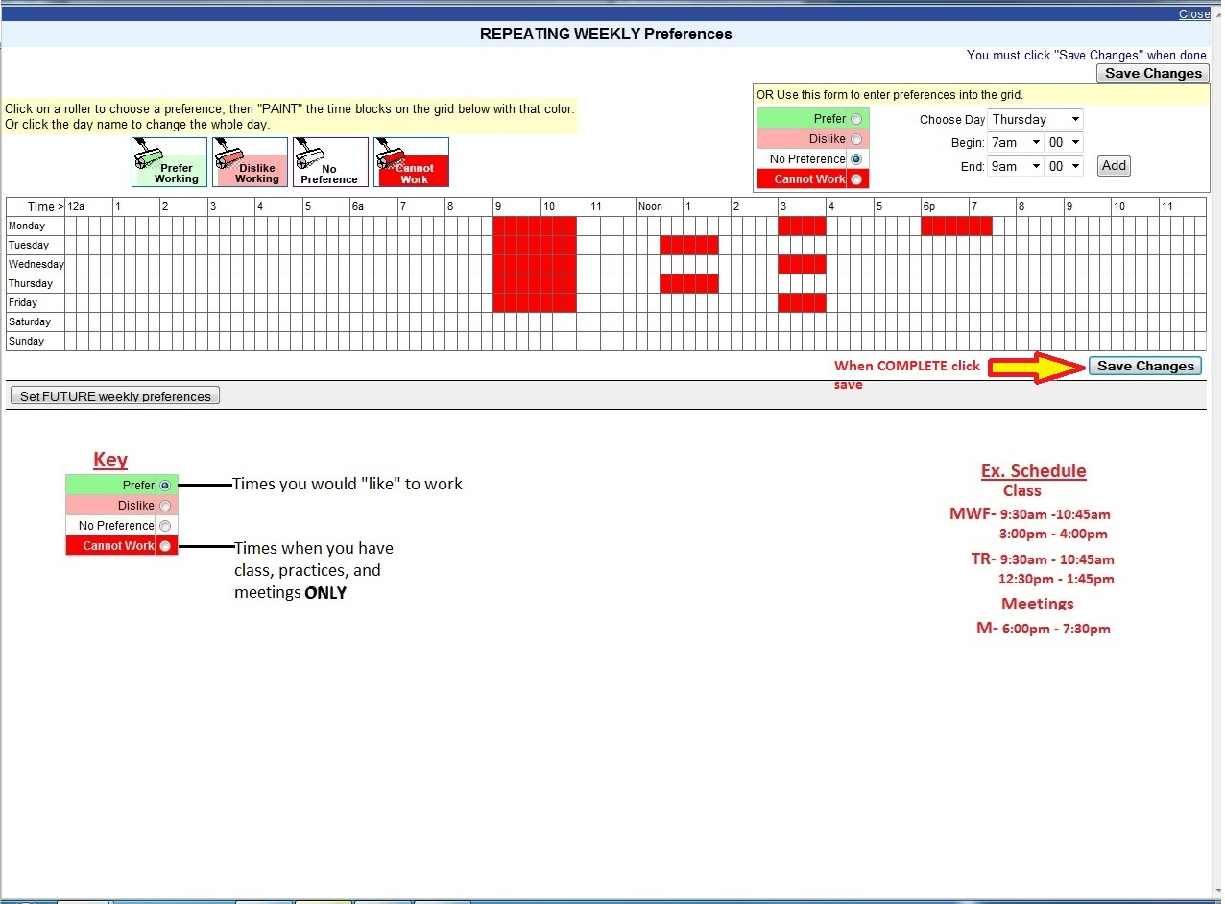
Setting Notifications:
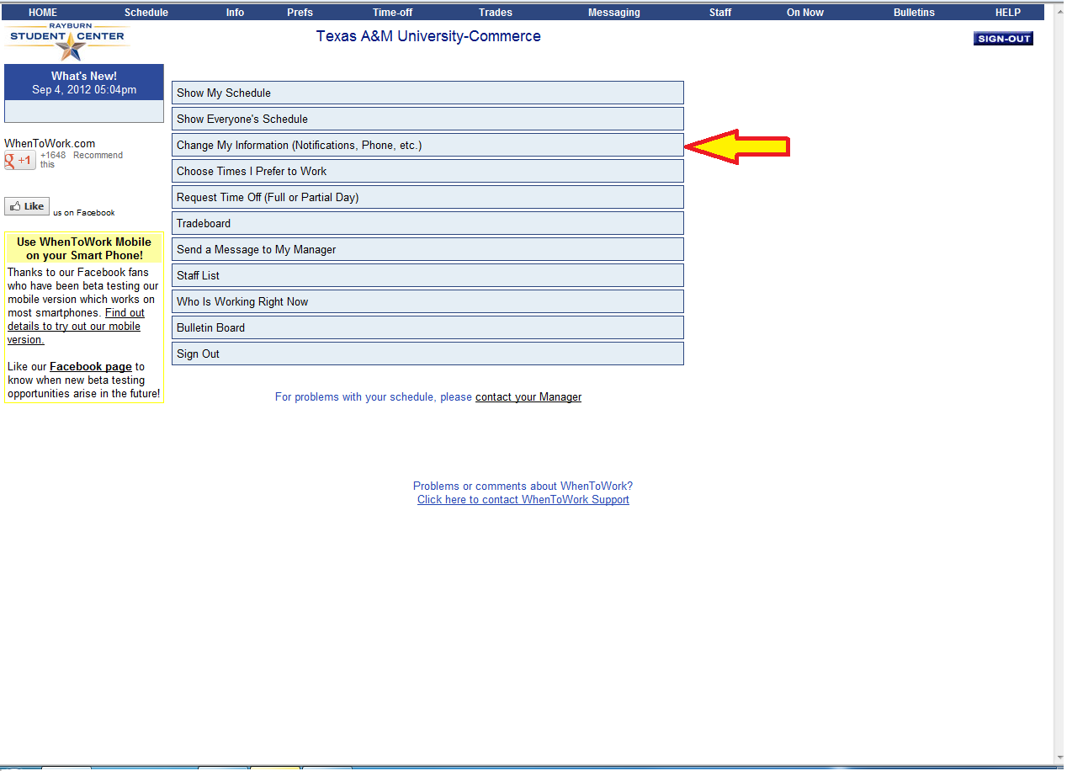
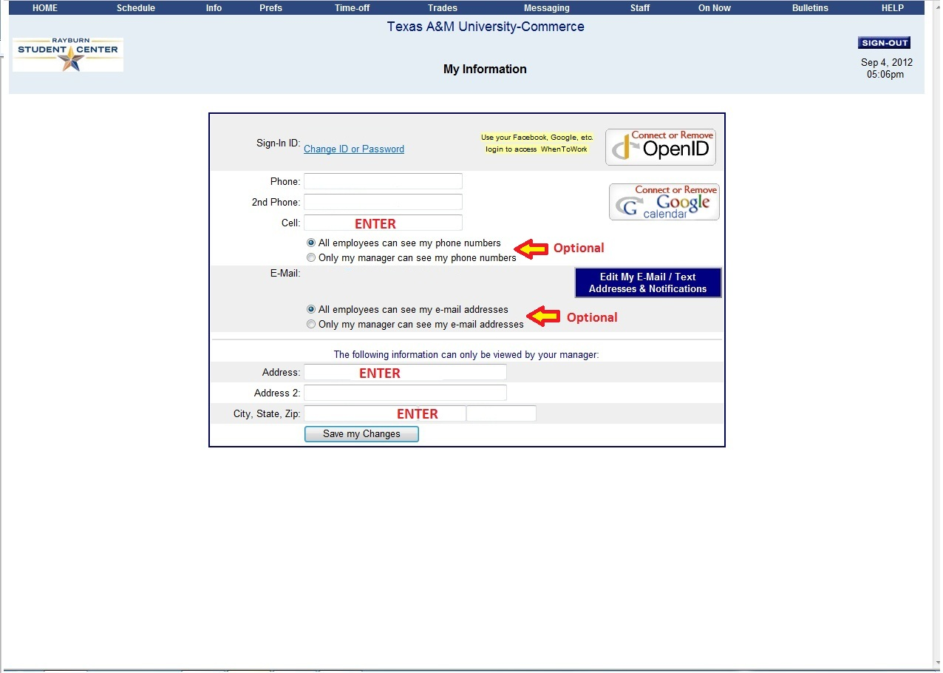
Trading Shifts:
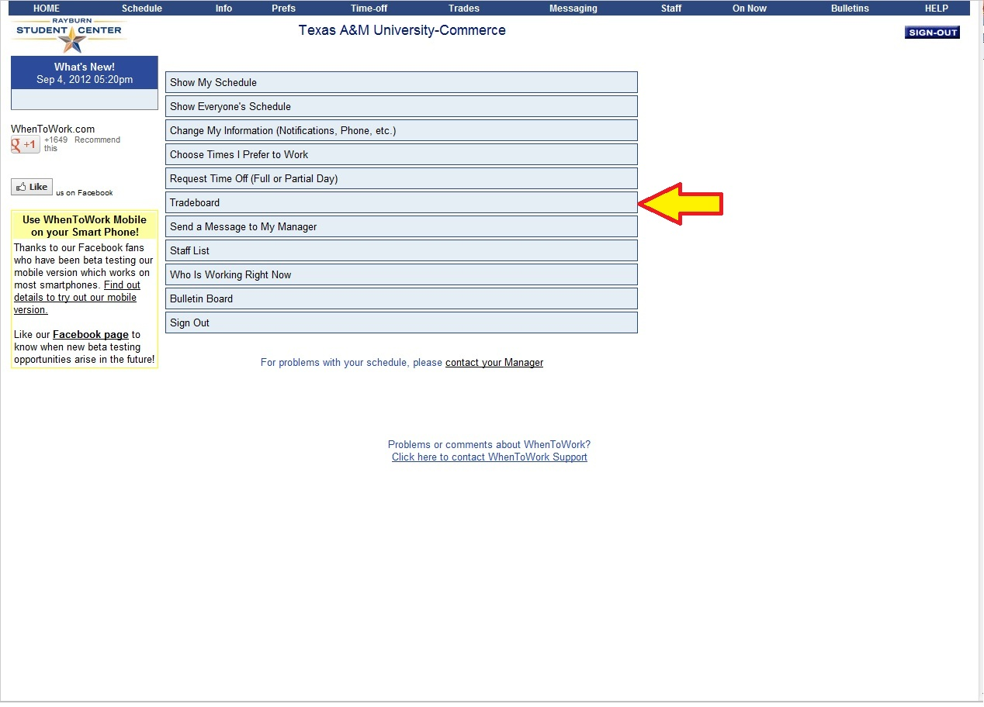
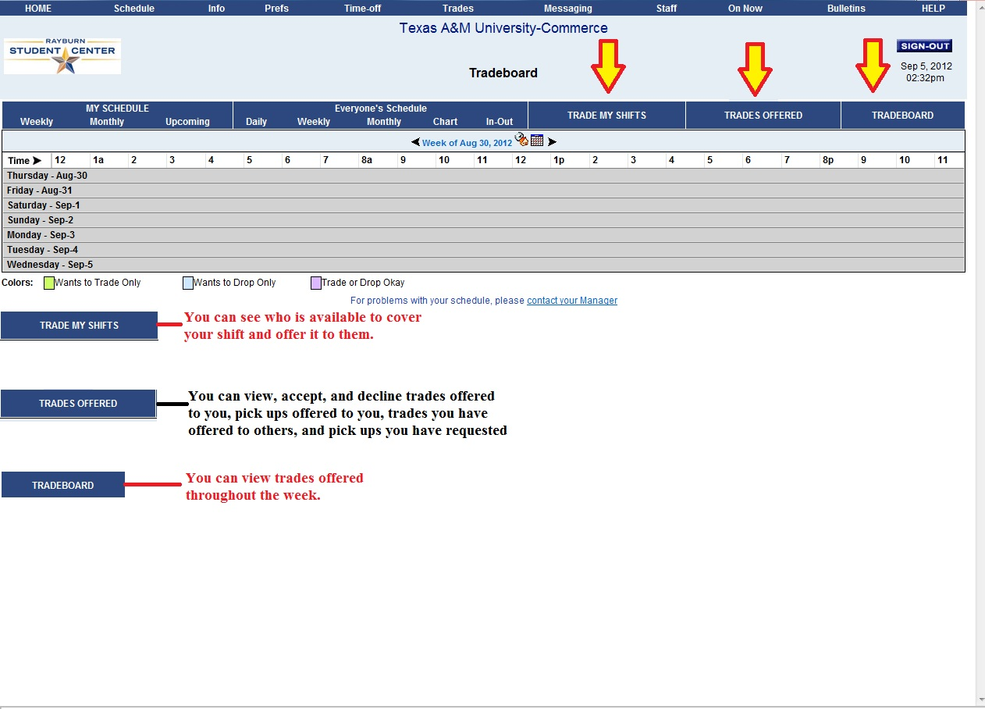
Requesting Time Off:
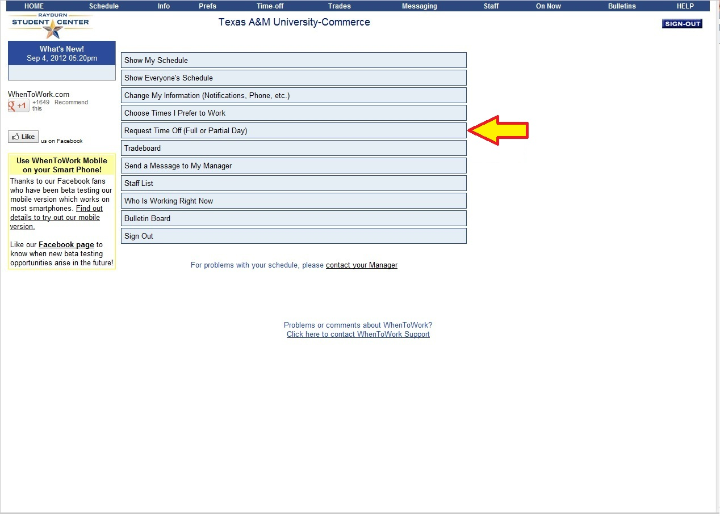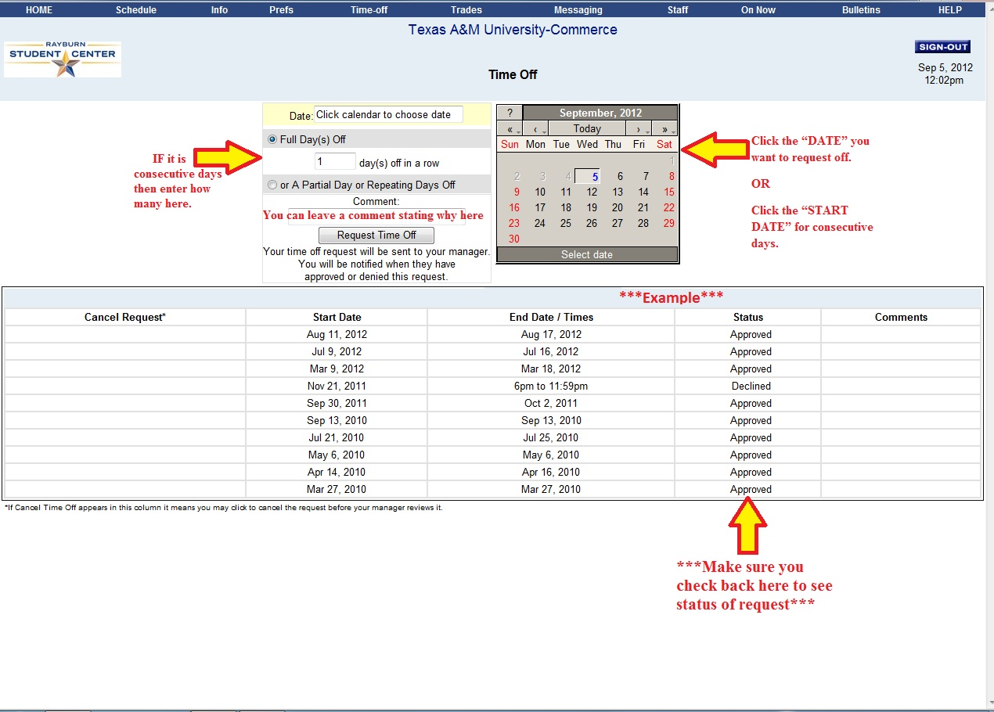
SSO
SSO: Program to submit hours, view pay stubs, hours worked for a pay period, and to do work related trainings.
1. Visit sso.tamus.edu
2. Enter “UIN” and “Password”
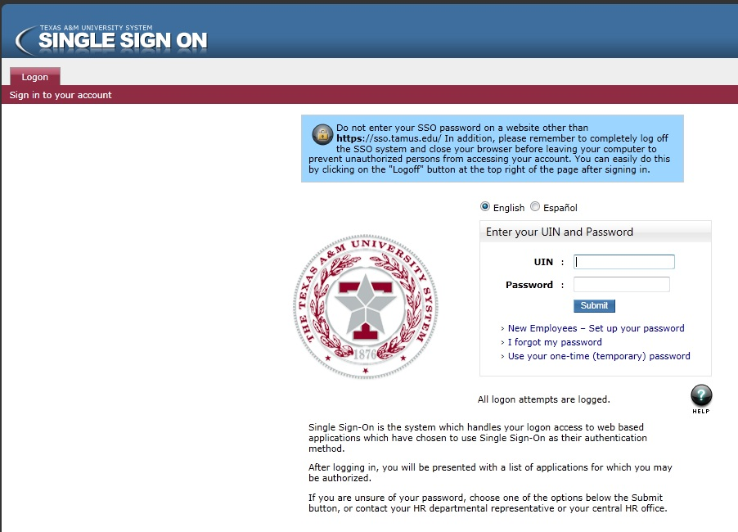
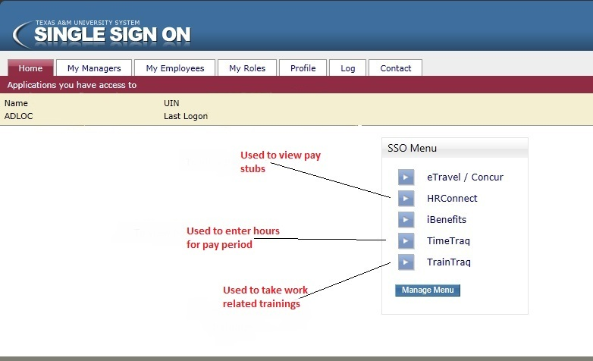
Submitting Hours:
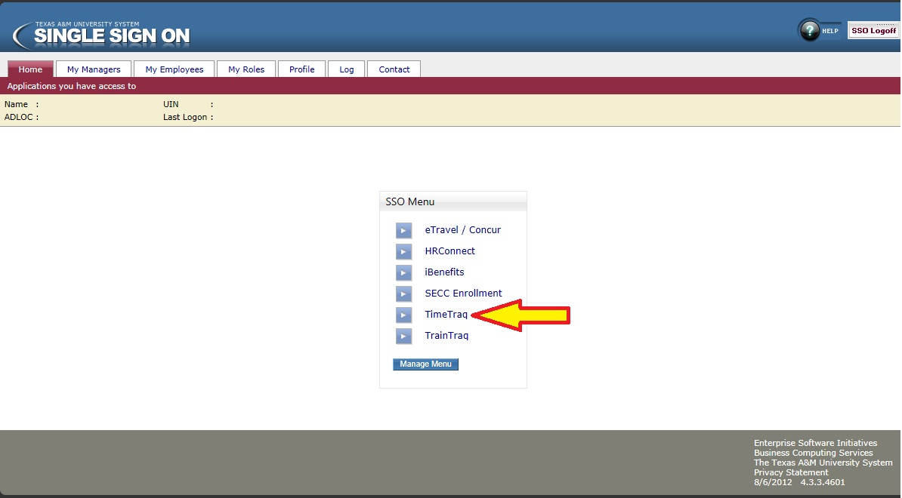
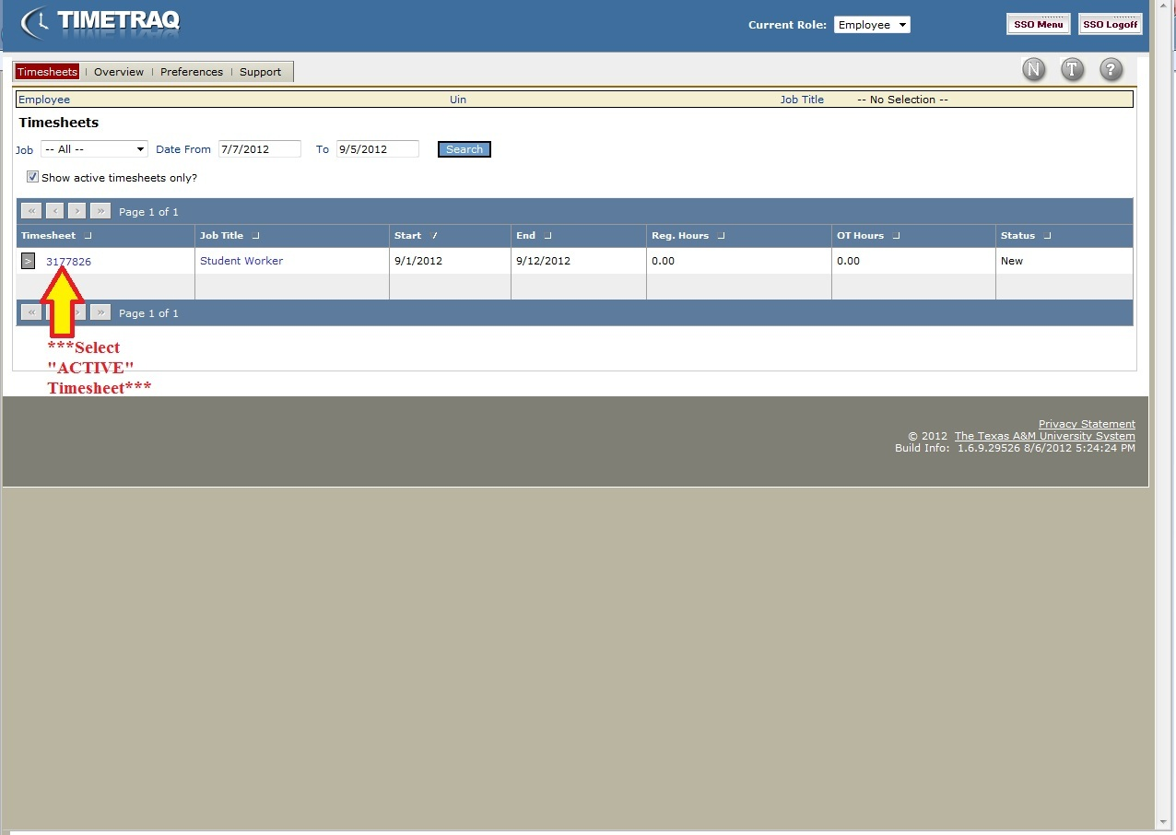
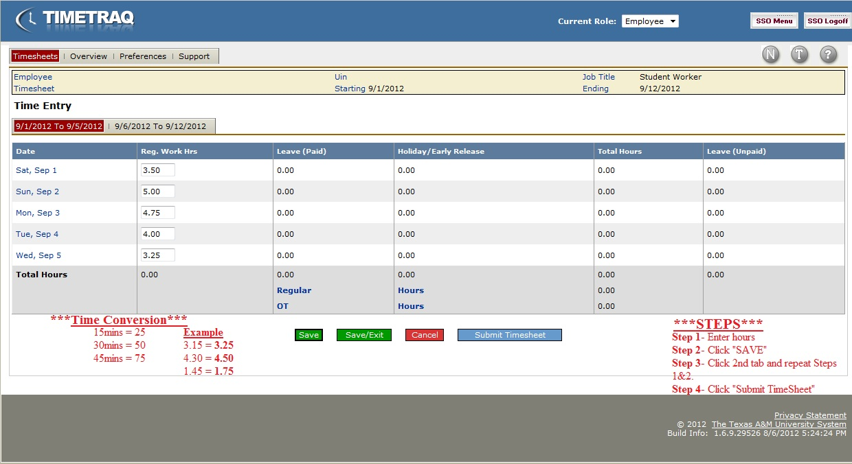
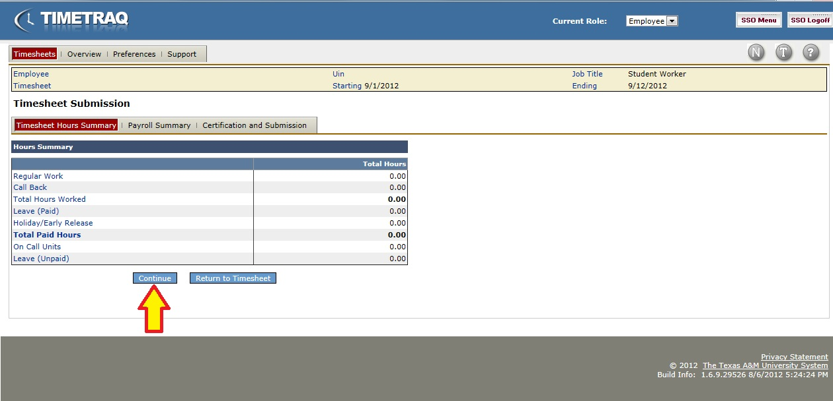
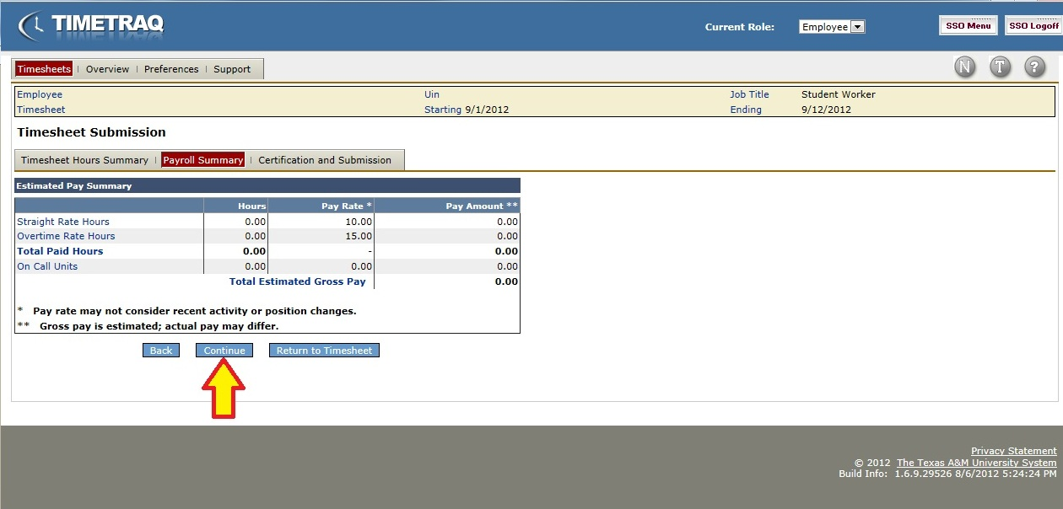
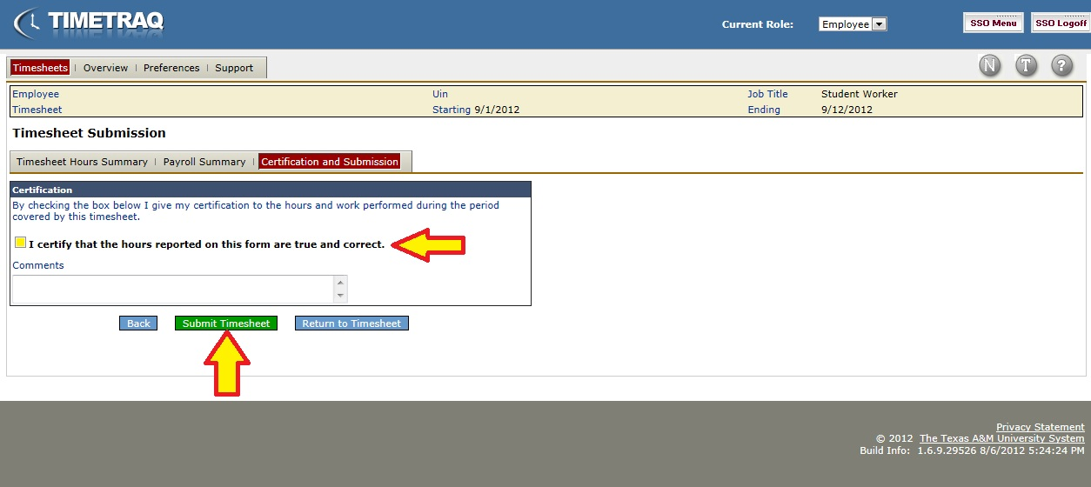
Time Clock Plus
1. Visit timeclockplus.tamu-commerce.edu/webclock30
2. Type your “UIN” where it says “Id/Badge Number”
3. Ignore where it says “Pin Number” and just hit login
4. Use the EXACT numbers you see on this website and NOT just putting what your scheduled. If you’re scheduled to work a 4 hour shift, but it shows that you worked 3 hours and 30 minutes then you will enter 3 hours and 30 minutes.

Checking Hours:
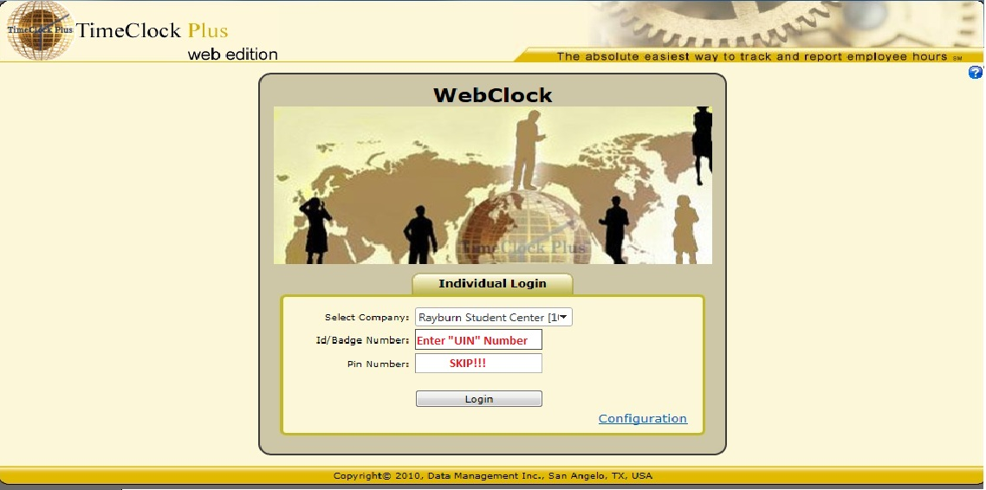
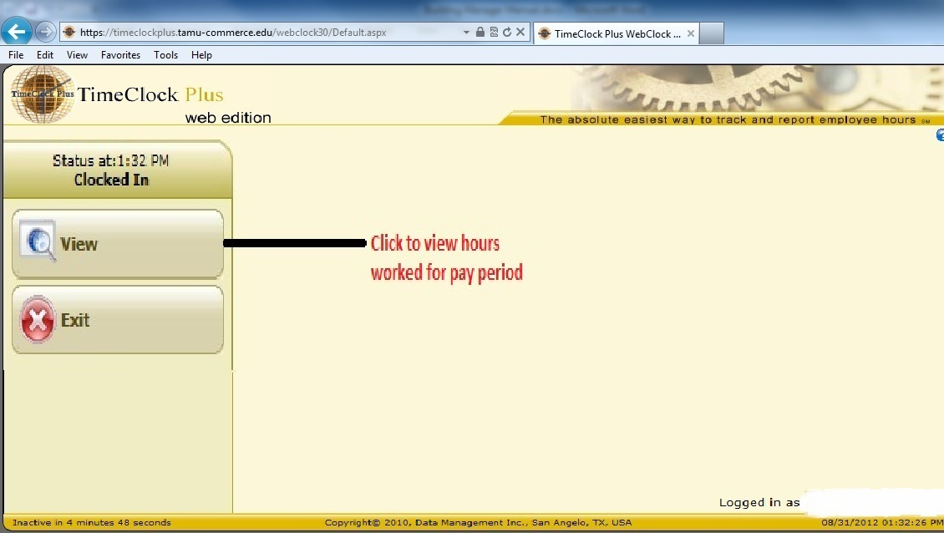
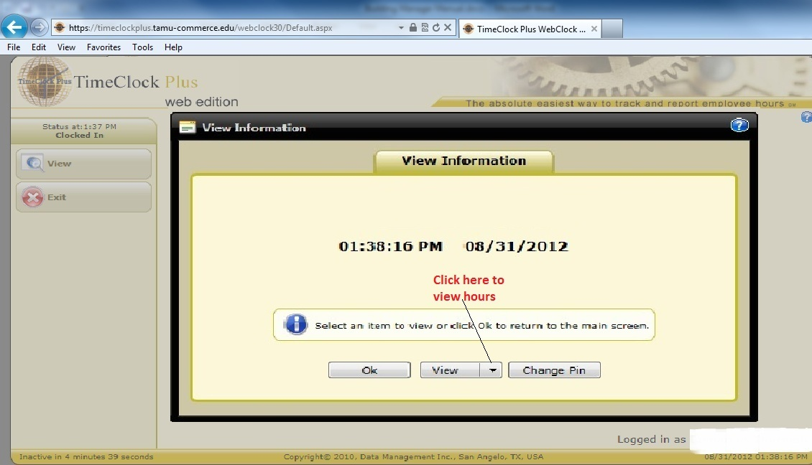

Training/Checklist
(MGR initials and Trainee)

Clock in and out _____ ______
When to Work _____ ______
Submitting Time Sheets _____ ______
Proper Radio Use _____ ______

Location of:
Table Storage (6 and 4 foot tables) (8 and 10 foot rounds) _____ ______
Dance Floor _____ ______
Stage Pieces (carpeted & hard side) _____ ______
Stairs for Stage _____ ______
Chair Storage _____ ______
Tablecloths _____ ______
Table Skirts _____ ______
Clips for skirts _____ ______
Drapes _____ ______
Stage Skirts _____ ______
Crank for Wall _____ ______
Plastic Tarp _____ ______
Reservation Sign Holders for Tables _____ ______
Dance Floor Spoon _____ ______
Centerpieces _____ ______
Projectors and screens _____ ______
Pipe and Bases _____ ______
Podiums _____ ______
Tea candles / mirrors for table top _____ ______
2 Tier Tables _____ ______
Partition Walls _____ ______
Grey Dolly _____ ______
Coat Racks _____ ______
Metal Detectors _____ ______
Extension Cords / Cord Cover _____ ______
Easels _____ ______
Portable White Board / Dry erase markers _____ ______
Flip Chart / Sharpie _____ ______

How To:
Read Set up Sheet _____ ______
Create a set up plan _____ ______
Put stage together/down _____ ______
Put dance floor together/apart _____ ______
Put Projector screen together/apart _____ ______
Open and Close walls (Conf. A, B, C, and Innov. A&B) _____ ______
Use Table and Chair Dolly _____ ______

