Building Manager Manual
Updated 2019

Job Description
Building Managers for the Rayburn Student Center will perform the highest level of customer service to visitors. Will be held responsible for opening and closing the building, supervising the welcome desk and club desk attendant, overseeing daily room setups and break downs, setting up basic technical and audio visual equipment , and other duties as assigned. Building Managers also will be trained in safety protocol and emergency procedures for the building. Building Managers will be required to meet expectations of the Rayburn Student Center, including becoming trained in CPR/First Aid/AED.

Rayburn Student Center Building Manager Area Training
Subitup: Checking schedules, Requesting Time Off, Checking Hours/Time Clock, Switching Shifts
Proper Radio Usage: Private Talk only, if someone Radios you on All Radios, Click home button on the radio, then private the user back.
Laundry Room: All linens, Washer and Dryer, Wall Crank, Door Stoppers, Blue and Gold Flowers, Mini sign stand holder, Dirty linen pile etc.
Storage Rooms: AV, Old chair/lift, new chair, cocktail tables, Rounds, Stage, Pipe and Drape etc.
Opening Procedures: How to properly open the building.
- Unlock doors by 7:00 AM (Mane Card side, Bookstore entrance, Rayburn Statue, Lion Café entrance, The Club Patio Doors) *Remember Switch Handicap doors
- Turn on All Tv’s and Rockbot in the Club *Turn on lights
- Pick up IPad and room cards
- Put out Room Cards, Event Schedule at the SIS desk, and Welcome Desk (has touch screen)
- Double check all rooms for event setup, and open the rooms that will be used.
- Check in with Ray and Joe for future setups.
- Check in with Michael for any issues in the morning.
- 8:00 AM check in with Welcome Desk * Report to Michael if no one is at the desk by 8:15 AM
- 10:00 AM check in with The Club Desk Attendant *Report to Michael if no one is at the desk by 8:15 AM
Closing Procedures: How to properly close the building.
- All A/V equipment returned to the rightful spot.
- Lounge Furniture and Atrium needs to be straightened.
- Close and lock all meeting rooms. (Any events that is completed, go ahead and lock up afterwards)
- Secure all doors 1st and 2nd floor (make sure to have your lion card to enter SIS and E&O suite) SIS and E&O locks at 5:00pm.
- Double Check The Club Doors to make sure they are locked.
- Return IPad and Keys to Elvis’ Office. *Charge IPad
Meeting Rooms: (Innovation A&B, Pride, Ambition A&B, Legacy A&B)
- In Room Computer (A/V Closet)
- Keyboard and Mouse A&B (A/V Closet)
- Touch Panel – Master Volume, Blinds, Projector, Screen, Desktop(In Room PC), Plate (Laptop))
- Use Wall Crank to secure Dividing Walls (Innovation A&B are different from other meeting rooms)
Meeting Rooms: (Vision, Traditions, Conference ABC, Loyalty, Inspiration)
- In room computers (Except Conference ABC)
- TV’s (Vision, Inspiration, Loyalty)
- Conference Phone ( Innovation A&B, Loyalty)
Conference ABC
- Stage, Dance Floor, Pipe and Drape, Microphone ABC, Laptop (Elvis’ Office)
- Big pop up screen, Center Conf C Screen
- Storage Closets ( 6fts, Rounds, Chairs, Dance Floor, Stage Steps, Podiums)
Building Manager (What to do on your shift)
- Setup rooms with Ray, Doug, Joe, and each other.
- Meet with Clients 15 minutes before the event, have room open and ready 30 minutes before. If they still haven’t arrived check regularly.
- Take attendance on 7pointops.
- Do manager reports (failure to do so will be disciplined)
- Do rounds, and check on events to see if they are ready to be flipped for the next event)
- Setup rooms for the next day.
- No manager should be at the Manager Desk, unless all rooms/ events are tended to. * Set rooms for tomorrow.
- Check on Welcome Desk and Club Desk. * Check the Club for cleanliness and report to Club Desk Worker.
- If asked by RSC Professional staff under John Weatherford, please help them with whatever they ask. Check with Elvis if you are confused. (If you can’t help them, tell them the reason why, i.e flipping rooms, checking events; if so, let them know when you can help them)
- Communicate with your coworkers, Ray, Doug, and Joe. Plan on what time to tackle a room when it is done with.
- Regularly do rounds around the building, any trash on the floor; pick them up.
- Maintain the building and communicate with SSC Staff for dirty/messy rooms.
- Return everything to the proper place.
- Don’t procrastinate.
- Follow up with events when they end.
- Gather any equipment left out, when doing rounds.
- Responsible for the positive appearance of the facility.
- Perform other duties as assigned to maintain operations and services.
Expectations
- Perform all duties in a professional manner, and in accordance with University and Rayburn Student Center safety regulations.
- Supervise the work of student staff.
- Arrange furniture and technical setups to meet the needs of clients utilizing the facility.
- Tend to any requests by guests in the Rayburn Student Center.
- Familiarize yourself with services and resources available at the student center.
- Properly arrange and maintain furniture and equipment in storage rooms.
- Responsible for securing breakout rooms and the facility when opening and closing.
- Review daily set-up worksheets upon arrival. Check with clients prior to each event to determine if all requests have been met.
- Periodically walk through the building and gather any equipment left out.
- Assist with signage directing guests to a special location when requested.
- Update and maintain bulletin boards in the Rayburn Student Center.
- Use appropriate radio communications with other staff (NO “all radios” communication)
- Dress code includes your name badge, radio, and proper uniform.
- Report any employee concerns, problems, or missing or broken equipment to the direct supervisor.
- Managers are expected to attend weekly meetings.
- Provide supervision of all public areas in the Rayburn Student Center during hours of operations.
- Managers are responsible for the positive appearance of the facility.
- Maintain and submit nightly the student center traffic flow document.
- Attend Weekly or Biweekly Manager Meeting
- Perform other duties as assigned to maintain operations and services.

Dress Code
Appropriate Attire
- RSC Polo
- Black, Blue, Khaki Pants or Jeans with no holes!!!
- Belt, so that your pants don’t sag.
- Closed Toed Shoes
- Name Badge
- RSC T- shirt (Fri-Sun)
- B&G Wednesday(RSC T-Shirt) with Jeans

Room Setups

Audience Classroom
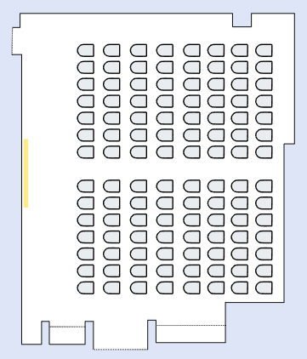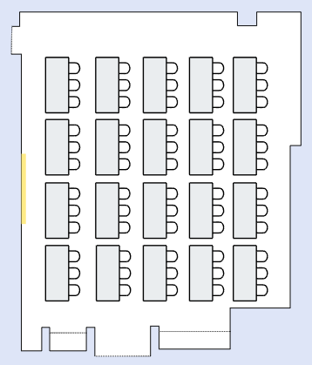

Open Square Closed Square
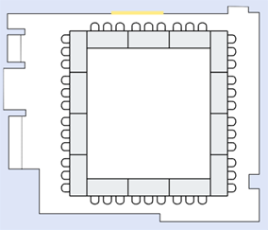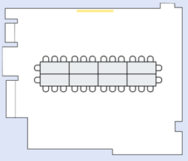

U – Shape Outside only U – Shape Outside / Inside
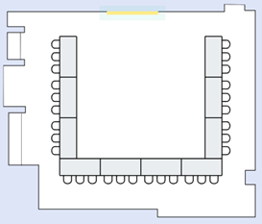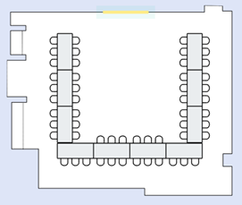

Disciplinary Actions

1. First offense will result in a “Verbal Warning”.
- Can be terminated for first offense if necessary
2. Second offense will result in a “Written Warning”.
- Can be terminated for second offense if necessary
3. Third offense will result in “Probation/Suspension”.
- Can be terminated for third offense if necessary
4. Fourth offense will result in “Termination”.

When dealing with Disciplinary Actions you will have the opportunity when called into your supervisor’s office to discuss the incident and what will occur if necessary.

