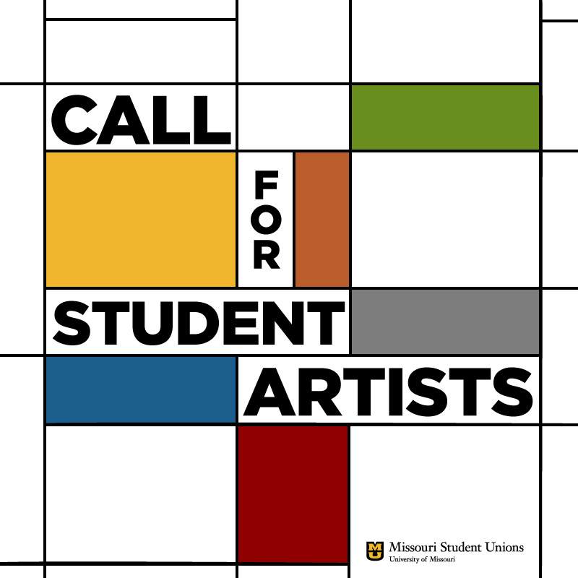
CALL FOR SUBMISSIONS OF ARTWORK
Contact: hdgh2@missouri.edu
Dai, Hongjue, Curator of Public Art
MU Student Center
The Missouri Student Unions requests submissions of artwork for temporary exhibition in the MU Student Center. This project aims to highlight the creative abilities of the MU community and provide a forum for the public display of the results of those abilities. Student artists are especially encouraged to submit. Submissions are requested in order to create a pool of artists from which future temporary exhibitions might be drawn. Submissions will be accepted on a rotating basis. There is no deadline for submission.
Suggested themes include student life, the diversity of the MU community, interpersonal expressions of creativity, or social justice issues. Submissions should not be limited to these suggested themes. Other subject matter may be considered as appropriate for our viewing audience.
Two-dimensional artworks may be displayed in hanging spaces located on the first floor or on the ground floor of the MU Student Center. Locations provide heat/humidity-controlled environments and limited contact with direct sunlight. Three-dimensional objects may be accepted for display within a locked case at the discretion of the Curator and Senior Unions Administration.
No monetary incentives are being offered for this project. Artists are responsible for the costs of producing their own artworks. No submission fees are required for entry. Artists will retain all rights to their work; however, the Missouri Student Unions may request permission to reproduce images of the artwork electronically with copyright retained by the artist. Artworks will be on loan to the Missouri Student Unions and artists will be required to sign a loan agreement. The purpose of the project is educational and not commercial, so artists should not expect monetary gain from exhibiting.
SUBMISSION REQUIREMENTS:
Submissions should be sent via email to hdgh2@missouri.edu.
1. Email cover letter included a short artist’s statement addressing the work submitted.
2. One to five (1-5) digital images as email attachments of each work submitted. Images should be presented in JPEG format with image size set to 300 dpi resolution, 4" x 6" image size, approximately.
3. Brief artist resume/CV including biography, educational background, and exhibition record, not to exceed 2 pages.
Selection Process: Submissions will be reviewed by the Curator of Public Arts and then submitted to senior Missouri Student Union staff members for final approval.
Notification to artist: Artists will be notified of the selection decision within 7-10 days of the receipt of email submission.
Accepted Artwork: Artists must be able to deliver artworks to the MU Student Center during regular business hours. Two-dimensional works on paper must be framed under glass. Works on mounted canvas should have an appropriate support structure to be evaluated by the Curator. Hanging hardware may be added to the frame by Unions staff in order to display the artwork.
Publicity: Exhibitions are publicized through the Unions’ Arts blog (http://unionsart.blogspot.com/), LED screens within the Union buildings and through authorized Unions social media accounts.
Sales: No public sales should be expected by any artists accepted for exhibition. No public sales will be facilitated by Unions staff.

